CASE STUDY REPORT
on
RAILWAY RESERVATION SYSTEM
Managing Ticket Booking, Cancellation and Seat Availability
Problem solved: Double booking (overbooking) and unmanaged cancellations
Submitted in partial fulfilment of the requirements of the course

Submitted by
Student Name | : Kavish
UID / Roll No. | : 25BCD10107
Programme / Branch | : BCA Data Science
Section / Group | : 25BCD 2B
Semester | : 3rd
Under the guidance of | : Mr. Jitendra Kumar
University Institute of Engineering / Computing
Chandigarh University, Gharuan, Mohali, Punjab
September 2026

CERTIFICATE
This is to certify that the case study report entitled "Railway Reservation System: Managing Ticket Booking, Cancellation and Seat Availability" is a bonafide work carried out by Kavish (UID: 25BCD10107), a student of BCA Data Science (Section 25BCD 2B, 3rd Semester), Chandigarh University, under my supervision, during the session 2026-27.
______________________
Project Guide
Mr. Jitendra Kumar
DECLARATION
I, Kavish, hereby declare that this case study report titled "Railway Reservation System: Managing Ticket Booking, Cancellation and Seat Availability" is my original work. Wherever the work of others has been used, it has been acknowledged in the references, and this work has not been submitted to any other institution for any degree or diploma.
Signature: ____________Kavish____________
Kavish (UID: 25BCD10107)
Date: 29/09/2026

ACKNOWLEDGEMENT
I sincerely thank my project guide, Mr. Jitendra Kumar, for the guidance and encouragement given throughout this case study, and the Head of the Department and faculty members for providing the laboratory facilities. I also thank Chandigarh University for the opportunity to connect classroom theory with a practical project, and my family and friends for their support.
Kavish
ABSTRACT
This case study examines a Railway Reservation System that manages ticket booking, cancellation and seat availability. The system is implemented in Python with an SQLite database and consists of an availability module, a booking module, a cancellation module and a reservation chart. Each ticket is either confirmed (CNF) with a seat number, waitlisted (WL), or cancelled (CAN).
A real-world problem is studied: when many users request the last few seats at the same moment, a check-then-insert booking routine sells the same seat more than once. A simulation of such legacy logic confirmed 10 tickets for only 3 seats. The problem is solved by making the check-and-allocate step atomic (a lock plus a database transaction), deriving availability from actual confirmed tickets instead of a stored counter, and promoting the first waitlisted passenger automatically when a confirmed ticket is cancelled.
In testing, 20 concurrent users competing for 3 seats produced exactly 3 confirmed tickets, 5 waitlisted tickets and no duplicate seats, and all ten test cases of the proposed system passed (the eleventh reproduces the legacy defect).
Keywords: Railway Reservation, Ticket Booking, Cancellation, Waitlist, Concurrency, Race Condition, SQLite

TABLE OF CONTENTS
Chapter 1: Introduction 5
1.1 Background 5
1.2 Problem Statement 5
1.3 Objectives 5
1.4 Scope 5
Chapter 2: Concepts Used 5
Chapter 3: Requirements 6
3.1 Functional Requirements 6
3.2 Business Rules 6
3.3 Software Requirements 6
Chapter 4: System Design 6
4.1 Architecture 6
4.2 Ticket Status Lifecycle 7
4.3 Database Design 7
4.4 Problem Analysis and Proposed Solution 7
Chapter 5: Implementation 8
Chapter 6: Testing and Output 9
6.1 Test Cases 9
6.2 Output Screenshots 9
Chapter 7: Conclusion and Future Scope 11
References 11
Appendix A: Complete Source Code 12

Chapter 1: Introduction

1.1 Background
Indian Railways carries millions of passengers every day, and a large share of them reserve seats in advance through online portals, mobile apps and station counters. A Railway Reservation System (RRS) is the software that makes this possible. Its core responsibility is simple to state but hard to implement correctly: show the right number of seats, sell each seat to exactly one person, and return the seat to the pool when a passenger cancels.

1.2 Problem Statement
During peak booking windows, such as the opening of advance reservation for a festival, hundreds of users request seats on the same train at the same instant. A straightforward implementation reads the number of free seats, checks that it is greater than zero and then inserts a ticket. Because these are separate steps, several requests can pass the check together and all of them book. The result is overbooking, duplicate seat numbers and passengers who reach the station with a ticket for a seat that does not exist.
A second problem is cancellation. If a freed seat is not offered to the waitlist immediately, the seat stays empty while genuine passengers remain unconfirmed. This case study reproduces both problems and solves them.

1.3 Objectives
- Model trains, travel dates, coach classes and seat inventory in a relational database.
- Provide real-time seat availability, including the waitlist count.
- Book tickets with automatic seat allocation (CNF) or waitlisting (WL) when a class is full.
- Cancel tickets, calculate the refund using a time-based policy and release the seat.
- Identify and eliminate overbooking caused by concurrent requests.

1.4 Scope
The system covers a single train route with two classes (Chair Car CC and Executive Chair EC), per-passenger tickets and a fixed waitlist limit. Payment gateways, user login, multi-station quotas and a graphical interface are outside the scope of this study.

Chapter 2: Concepts Used
Transaction and atomicity. A transaction groups several database operations so that they either all succeed or all fail. Booking reads availability and inserts a ticket inside one transaction.
Race condition (TOCTOU). A time-of-check to time-of-use race occurs when the state checked by a program changes before the program acts on it. The double-booking defect in this study is a race condition.
Mutual exclusion (lock). A lock allows only one thread at a time to run a critical section. Wrapping the check-and-allocate step in a lock guarantees that two requests can never receive the same seat.
Derived data. Available seats are computed from the count of confirmed tickets, not kept in a separate counter, so the displayed number can never disagree with the reservation chart.
FIFO queue. The waitlist is ordered by booking sequence (first in, first out), which is fair to passengers who booked earlier.

Chapter 3: Requirements

3.1 Functional Requirements
Table 3.1: Functional requirements
ID | Requirement | Description
FR1 | Seat availability | Show total seats, available seats, waitlist count and fare for a train, date and class.
FR2 | Book ticket | Allocate the lowest free seat (CNF) or add the passenger to the waitlist (WL).
FR3 | PNR generation | Issue a unique PNR to every booking request that is accepted.
FR4 | Cancel ticket | Mark the ticket CAN, free its seat and compute the refund.
FR5 | Waitlist promotion | On cancellation of a CNF ticket, promote the oldest WL ticket to CNF.
FR6 | Reservation chart | List every active passenger with PNR, age, status and seat.
FR7 | Concurrency safety | Never sell more confirmed tickets than the seats available.

3.2 Business Rules
Table 3.2: Business rules enforced by the system
Rule | Value
Seat capacity (demo train 12001) | CC: 5 seats at Rs. 780; EC: 3 seats at Rs. 1450
Waitlist limit per class | 5 tickets; further requests are rejected
Refund: more than 2 days before travel | 75% of fare
Refund: 1 to 2 days before travel | 50% of fare
Refund: less than 1 day before travel | 25% of fare
Refund: waitlisted ticket | 90% of fare

3.3 Software Requirements
Any operating system (Windows, Linux or macOS) with Python 3.8 or later. The program uses only the standard library (sqlite3, threading and datetime). No external packages are needed.

Chapter 4: System Design

4.1 Architecture
The user sends a request to one of three modules. Booking and cancellation pass through a single lock and a database transaction before touching the SQLite database, which is what makes them safe under concurrent load.
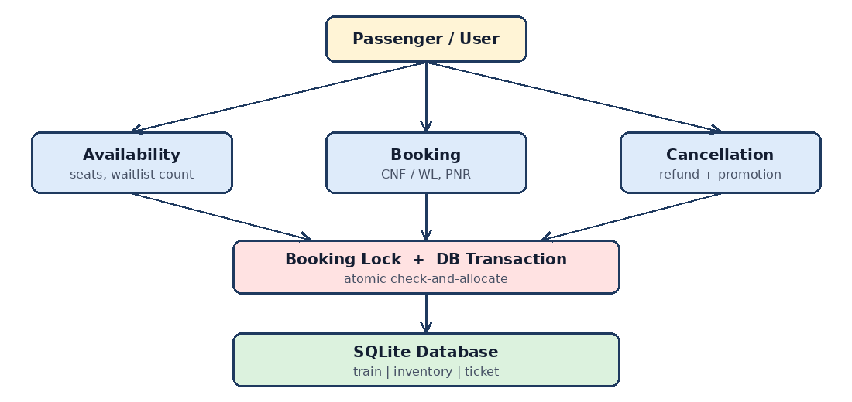
Figure 4.1: Architecture of the Railway Reservation System

4.2 Ticket Status Lifecycle
Table 4.1: Ticket status values
Status | Meaning | Allowed next state
CNF | Confirmed, seat number assigned | CAN
WL | Waitlisted, no seat yet | CNF (on a cancellation), CAN
CAN | Cancelled, refund issued | None (final)

4.3 Database Design
Table 4.2: Database tables
Table | Key columns | Purpose
train | no (PK), name, src, dst | Train master data
inventory | train_no, travel_date, cls (composite PK), total, fare | Seats and fare per train, date and class
ticket | pnr (PK), train_no, travel_date, cls, name, age, status, seat, fare, booked_seq | One row per passenger booking

4.4 Problem Analysis and Proposed Solution
To prove the defect, the legacy check-then-insert logic was simulated with 10 concurrent users and 3 available seats, with a short delay standing in for database latency. Seven extra tickets were issued.
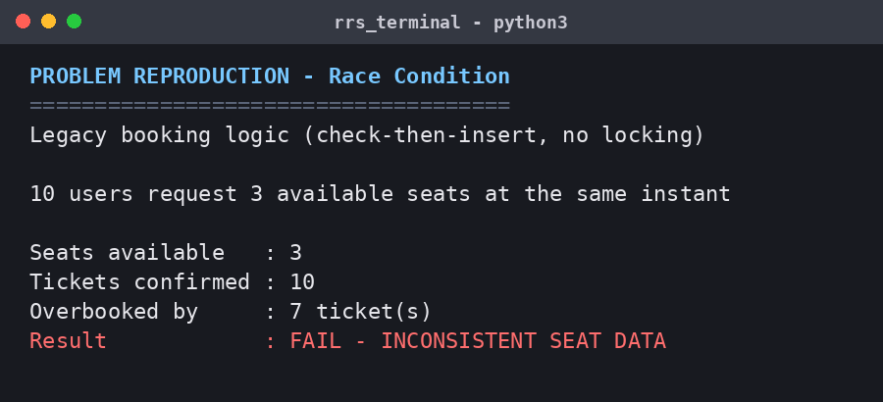
Figure 4.2: Legacy logic confirms 10 tickets for 3 seats (race condition)
Root causes: (a) the availability check and the ticket insert are not one indivisible step; (b) a separately stored seats-left counter can drift from the real tickets; (c) there is no automatic link between a cancellation and the next waitlisted passenger.
Table 4.3: Design decisions that solve the problem
Decision | Reason
Atomic check-and-allocate under a lock and a transaction | Only one request evaluates availability and inserts at a time, so two users never receive the same seat.
Availability derived from CNF ticket count | Single source of truth, no counter to desynchronise.
Lowest free seat allocation | Deterministic, and reuses seats released by cancellations.
FIFO waitlist ordered by booking sequence | Earlier waitlisted passengers are promoted first.
Waitlist limit and slab-based refund | Rejects over-limit requests cleanly and discourages late cancellations.

Chapter 5: Implementation
The program is written in Python 3 using an in-memory SQLite database and is organised as one class, RRS, with the methods add_train, availability, book, cancel, chart and get. The full listing is in Appendix A. The key logic is shown below.
Booking (atomic check-and-allocate). The lock and the transaction ensure that availability is read and the ticket is inserted as one indivisible step.
def book(self, no, d, cls, name, age):
with self.lock: # atomic check-and-allocate
self.db.execute('BEGIN')
av = self.availability(no, d, cls)
if av['available'] > 0:
seat = self._free_seat(no, d, cls, av['total']); status = 'CNF'
elif av['waitlist'] < 5:
seat = None; status = 'WL'
else:
self.db.execute('ROLLBACK'); return None
# insert ticket with new PNR, then COMMIT
Cancellation with waitlist promotion. After the refund is computed, the freed seat is handed to the oldest waitlisted ticket in the same transaction.
self.db.execute("UPDATE ticket SET status='CAN', seat=NULL WHERE pnr=?", (pnr,))
if status == 'CNF': # auto-promote first waitlisted passenger
nxt = self.db.execute("SELECT pnr,name FROM ticket WHERE ... AND status='WL' "
"ORDER BY booked_seq LIMIT 1", (no, d, cls)).fetchone()
if nxt:
self.db.execute("UPDATE ticket SET status='CNF', seat=? WHERE pnr=?", (seat, nxt[0]))
The test scenario uses Train 12001 Shatabdi Express (New Delhi to Chandigarh) on 10 November 2026. A small inventory (5 CC seats, 3 EC seats) makes the full, waitlisted and cancelled states easy to observe.

Chapter 6: Testing and Output

6.1 Test Cases
Table 6.1: Test cases and results
ID | Input | Expected result | Result
TC01 | Search train 12001, CC, 10 Nov | Total 5, available 5, waitlist 0 | Pass
TC02 | Book first CC passenger | CNF, seat 1 | Pass
TC03 | Book five CC passengers | CNF with seats 1 to 5 | Pass
TC04 | Book 6th and 7th when CC full | WL, no seat; available 0, waitlist 2 | Pass
TC05 | Cancel a CNF ticket (more than 2 days) | Refund Rs. 585; first WL becomes CNF with freed seat | Pass
TC06 | Cancel a waitlisted ticket | Refund Rs. 702 (90%) | Pass
TC07 | Cancel 1 to 2 days before travel | Refund Rs. 390 (50%) | Pass
TC08 | Cancel on the day of travel | Refund Rs. 195 (25%) | Pass
TC09 | Cancel an already cancelled or unknown PNR | Request rejected | Pass
TC10 | 20 concurrent bookings for 3 EC seats | 3 CNF, 5 WL, 12 rejected, no duplicate seats | Pass
TC11 | Legacy logic: 10 concurrent users, 3 seats | Should confirm 3; confirms 10 | Fail (defect reproduced)

6.2 Output Screenshots
The screenshots below were captured from the program running in a terminal.
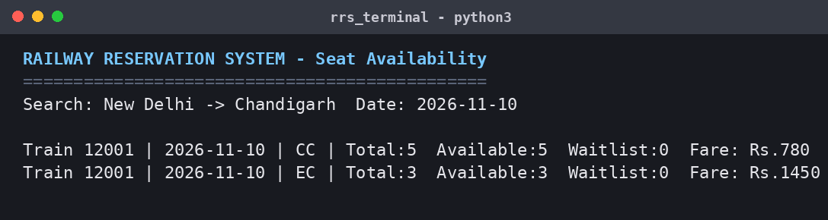
Figure 6.1: Seat availability search result
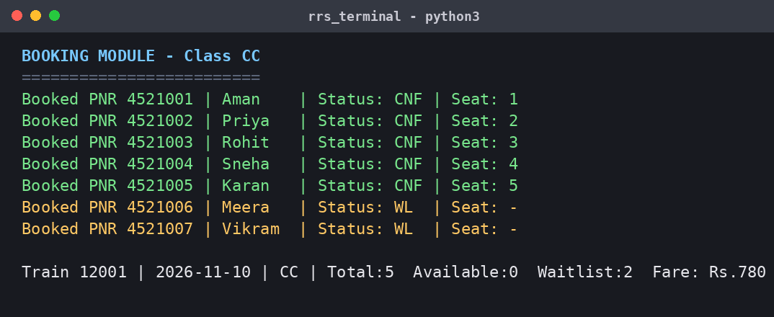
Figure 6.2: Booking module, confirmed and waitlisted tickets
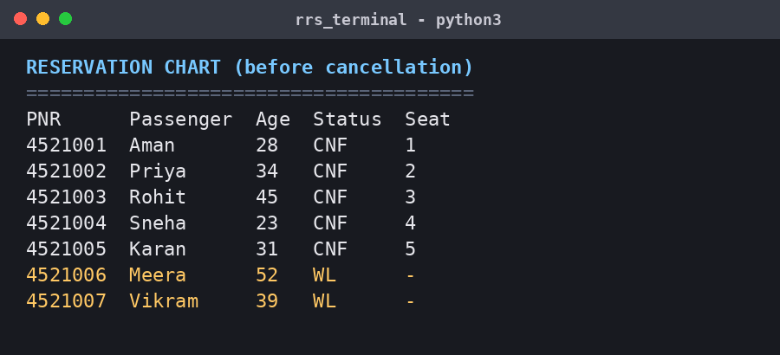
Figure 6.3: Reservation chart before any cancellation
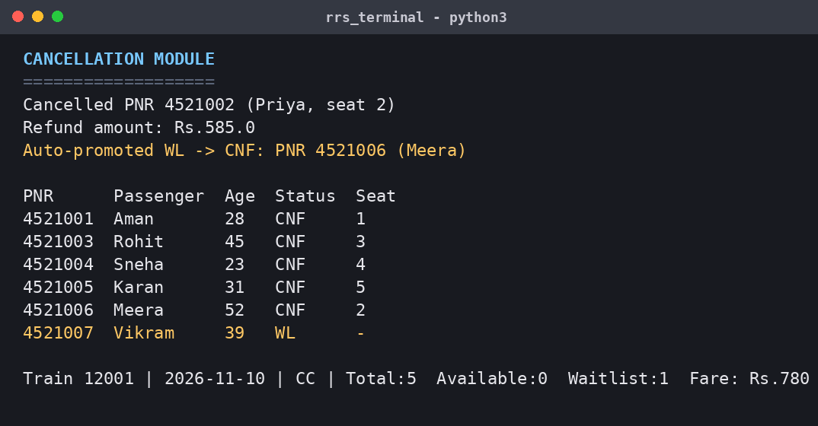
Figure 6.4: Cancellation, 75% refund and automatic promotion of WL to CNF
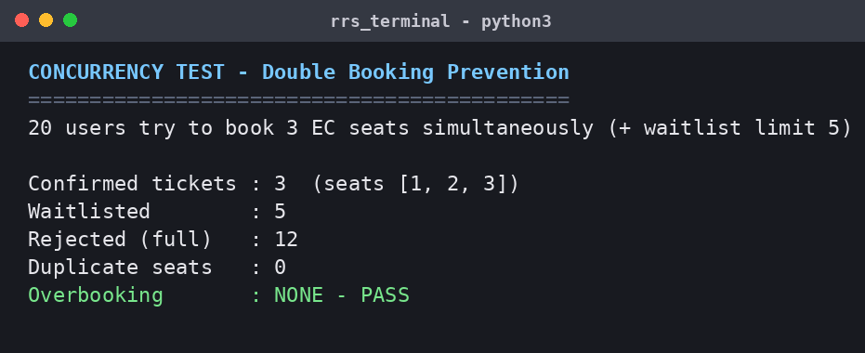
Figure 6.5: Concurrency test, no overbooking with the atomic booking logic
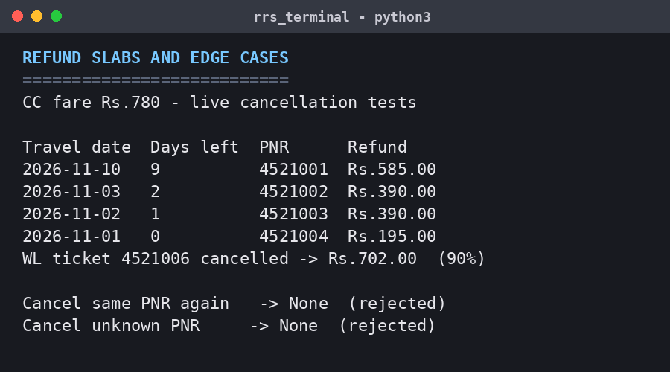
Figure 6.6: Refund slabs and edge cases (live results)

Chapter 7: Conclusion and Future Scope
The case study shows that the heart of a reservation system is the correctness of its inventory logic. A check-then-insert booking routine oversold a 3-seat class to 10 passengers under concurrent load. Making the check-and-allocate step atomic, deriving availability from real tickets and linking cancellations to waitlist promotion gave a system that never overbooked in testing, reused released seats immediately and computed refunds consistently. The same principles apply to any system that sells a limited resource, such as cinema seats, flights or hotel rooms.
Limitations: a single in-process lock serialises all bookings, which is correct for one server but would be a bottleneck at national scale; the model handles one journey segment; and the demo uses a fixed reference date (1 November 2026) for refund calculation.
Future scope:
- Per train, date and class locks, or SELECT ... FOR UPDATE in a production database such as PostgreSQL.
- RAC status, berth preferences, quotas (Tatkal, Ladies, Senior Citizen) and segment-wise availability.
- Payment integration, SMS and email notification, and a web or mobile front end with a seat map.

References
[1] Indian Railways Passenger Reservation System (PRS) and IRCTC public booking and cancellation rules.
[2] Silberschatz, A., Korth, H. and Sudarshan, S., Database System Concepts, McGraw-Hill.
[3] Python Software Foundation, Python documentation: threading and sqlite3 modules, docs.python.org.
[4] SQLite documentation: Transactions and isolation, sqlite.org.

Appendix A: Complete Source Code
File: rrs.py (the demo script that produced the screenshots calls these methods).
"""Railway Reservation System - booking, cancellation, seat availability.
Solves: double booking of last seat + unmanaged cancellations (waitlist auto-promotion)."""
import sqlite3, random, threading
from datetime import date

class RRS:
def __init__(self):
self.db = sqlite3.connect(":memory:", check_same_thread=False, isolation_level=None)
self.lock = threading.Lock()
self.pnr_seq = 4521000
c = self.db.cursor()
c.executescript("""
CREATE TABLE train(no TEXT PRIMARY KEY, name TEXT, src TEXT, dst TEXT);
CREATE TABLE inventory(train_no TEXT, travel_date TEXT, cls TEXT, total INT, fare REAL,
PRIMARY KEY(train_no, travel_date, cls));
CREATE TABLE ticket(pnr INTEGER PRIMARY KEY, train_no TEXT, travel_date TEXT, cls TEXT,
name TEXT, age INT, status TEXT, seat INT, fare REAL, booked_seq INT);
""")
def add_train(self, no, name, src, dst, d, cls_info):
self.db.execute("INSERT INTO train VALUES(?,?,?,?)", (no, name, src, dst))
for cls, (total, fare) in cls_info.items():
self.db.execute("INSERT INTO inventory VALUES(?,?,?,?,?)", (no, d, cls, total, fare))
def availability(self, no, d, cls):
total, fare = self.db.execute("SELECT total,fare FROM inventory WHERE train_no=? AND travel_date=? AND cls=?",
(no, d, cls)).fetchone()
used = self.db.execute("SELECT COUNT(*) FROM ticket WHERE train_no=? AND travel_date=? AND cls=? AND status='CNF'",
(no, d, cls)).fetchone()[0]
wl = self.db.execute("SELECT COUNT(*) FROM ticket WHERE train_no=? AND travel_date=? AND cls=? AND status='WL'",
(no, d, cls)).fetchone()[0]
return dict(total=total, available=total-used, waitlist=wl, fare=fare)
def _free_seat(self, no, d, cls, total):
taken = {r[0] for r in self.db.execute(
"SELECT seat FROM ticket WHERE train_no=? AND travel_date=? AND cls=? AND status='CNF'", (no, d, cls))}
for s in range(1, total+1):
if s not in taken: return s
return None
def book(self, no, d, cls, name, age):
with self.lock: # atomic check-and-allocate (fix for double booking)
self.db.execute("BEGIN")
av = self.availability(no, d, cls)
self.pnr_seq += 1; pnr = self.pnr_seq
if av["available"] > 0:
seat = self._free_seat(no, d, cls, av["total"]); status = "CNF"
elif av["waitlist"] < 5:
seat = None; status = "WL"
else:
self.db.execute("ROLLBACK"); return None
self.db.execute("INSERT INTO ticket VALUES(?,?,?,?,?,?,?,?,?,?)",
(pnr, no, d, cls, name, age, status, seat, av["fare"], pnr))
self.db.execute("COMMIT")
return pnr
def cancel(self, pnr):
with self.lock:
self.db.execute("BEGIN")
row = self.db.execute("SELECT train_no,travel_date,cls,status,seat,fare FROM ticket WHERE pnr=?", (pnr,)).fetchone()
if not row or row[3] == "CAN":
self.db.execute("ROLLBACK"); return None
no, d, cls, status, seat, fare = row
days = (date.fromisoformat(d) - date(2026, 11, 1)).days
rate = 0.75 if days > 2 else (0.50 if days >= 1 else 0.25)
if status == "WL": rate = 0.90
refund = round(fare * rate, 2)
self.db.execute("UPDATE ticket SET status='CAN', seat=NULL WHERE pnr=?", (pnr,))
promoted = None
if status == "CNF": # auto-promote first waitlisted passenger
nxt = self.db.execute("SELECT pnr,name FROM ticket WHERE train_no=? AND travel_date=? AND cls=? AND status='WL' ORDER BY booked_seq LIMIT 1",
(no, d, cls)).fetchone()
if nxt:
self.db.execute("UPDATE ticket SET status='CNF', seat=? WHERE pnr=?", (seat, nxt[0]))
promoted = nxt
self.db.execute("COMMIT")
return refund, promoted
def chart(self, no, d, cls):
return self.db.execute("SELECT pnr,name,age,status,IFNULL(seat,'-') FROM ticket WHERE train_no=? AND travel_date=? AND cls=? AND status!='CAN' ORDER BY booked_seq",
(no, d, cls)).fetchall()
def get(self, pnr):
return self.db.execute("SELECT pnr,name,status,IFNULL(seat,'-'),fare FROM ticket WHERE pnr=?", (pnr,)).fetchone()

